Emergent Behavior and Changes in Satisfaction of Skaters on an Ice Rink

Emergent behavior in complex systems is significant to the social sciences because it helps to explain unanticipated global interactions that spawn from local agent behavior. One environment where emergent behavior can appear is in ice skating rinks, which relates to flocking patterns as each skater follows the direction of its nearby skaters. Performing a simulation on an ice rink may provide nuanced results on flocking behavior. A model of the system of skaters in an ice rink was simulated to analyze emergent movements and trends in satisfaction among different members in the rink.

Regarding past research, Broad conducted research on skaters using sensor foot pressure data and mapped out the foot placement in backward cross-overs. This paper proves that the general pattern of skaters follow curves composed of many smaller circles according to Figure 3.8 and that the true population mean speed of elite skaters is, on average, above that of recreational skaters1. The stylized fact is that skaters tend to move in circular bumps as they perform cross-overs and elite skaters are on average faster than recreational skaters. Another study was performed by Kim and Kim on 45 Korean high school students and 232 undergraduate students that participated in 4 physical activities including figure skating. They were found to notably have lower psychological distress and higher well-being from ice skating2. A stylized fact from this study is that skaters, on average, tend to experience alleviation while skating on the ice. A research paper published by Mapelli et al discussed about the movements of skaters in ice rinks when performing back spins. Researchers used a optoelectronic motion capture system to detect patterns in the movement of skaters, which resulted in small circles that taper off in larger, global, circular motions on the ice. Thus, a stylized fact from back spin research would be that ice skaters tend to move in large circles composed of smaller circles in areas of the rink where they spin most often3. Research conducted by Pappas et al on hockey skating participants that found aggressive interpersonal relationships among male hockey players, which implies that another stylized fact for ice skaters is that hockey players tend to be conflictual skaters4. Pavlos et al have found birds to flock toward sinks, or attractors, in an environment while avoiding obstacles, repulsions, modeled using Wireless Sensor Networks, where the stylized fact is that group flocking behavior tends to involve one member moving according to whether they are attracted or repelled away from other birds or obstacles5. Injuries on public figure skaters has been research by Radford et al, where they took a prospective survey on injuries inflicted by members of the public skating in a popular rink in the city. Although most injuries are minor, skaters report injuries 31% of the time among all their attendances6. The stylized fact from this study would be that, on average, skaters tend to experience minor injuries 31% of the time. Emergent behaviors among skaters in an ice rink is a pressing research problem because of the lack of research about constrained flocking interactions. We want to analyze emergent movement in a constrained space (ice rink) and how the skaters’ movements affect their satisfactions because it not only proves previous literature as aforementioned, but also sheds light on how hockey skaters, professional and beginner figure skaters all interact.

Having generated the model in NetLogo, the ‘skaters in a rink’ model comprise of skater agents with 3 types: beginner (speed of 0.2 with low turning ability of 1), hockey (speed of 1.2 with a moderate turning ability of 2), and professional (speed of 0.7 with the highest turning ability of 3). The skaters have satisfactions (quantified skater alleviation), speeds, turning abilities (ability to avoid obstacles), skater neighbors (nearby), the closest skater to them and the time that a skater waits before getting up after he or she has fallen. When the ice rink simulation begins, the skaters have their satisfaction increased by 2.5 points because a unit tick increase leads to 2.5 more satisfaction. They then move forward at their skater speed and when a skater is within 3 patches of the rink’s outer edges, the skater will decide to either turn left or right initially with equal probability. The model is intended to self-organize as more skaters turning left will increase the probability of others turning left and skaters who turn right will increase the chances of others turning right. In the diagram on the left below, the outer yellow dashed circle and inner square enclose an area where most skaters move. The middle diagram displays randomly allocated skaters in the rink. The right diagram exhibits the rink with fallen skaters.

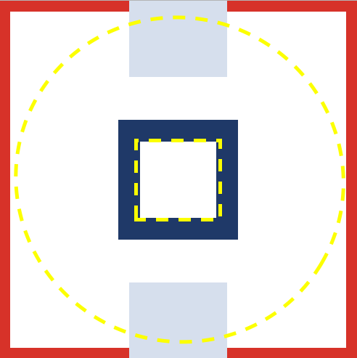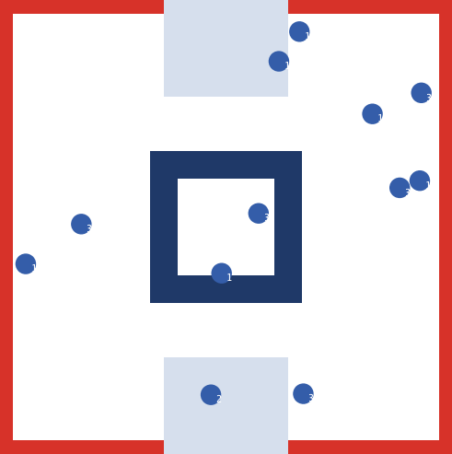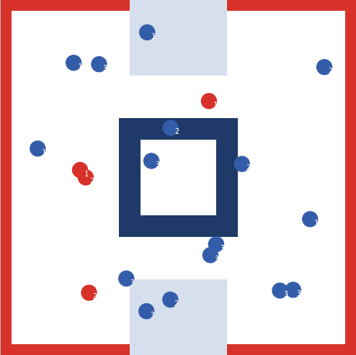

Given that a skater is able to turn based on if they’re not traveling too quickly and have a sufficient turning ability, they will be able to turn away from their nearest skater. Otherwise, they will run into their nearest skater. Then the skaters follows flocking behavior. Regarding agent interaction, the skater agents are modeled using a typical flocking model. Flocking behavior is modeled as following the skater’s nearest neighbors. First, if there are skater neighbors around the skater and the closest skater to them is lower than the minimum separation set by the slider in the model, the skater would avoid crowding and turn away from the direction of the nearest skater agent. Otherwise, if the closest skater is further than the minimum separation then each skater agent will turn towards the aggregate direction of their neighbors and then adhere their movement more closely to the direction of the nearby skaters by turning towards the average direction of the nearby skaters. If two skater agents collide, they will turn red to signify that they have fallen, have their satisfaction decrease by 5 points upon impact then decrease by 0.35 each second afterwards and stop for their wait time, after which they will get back up and move.

In this skating model, the key parameters, or inputs, are the wait times of the skaters and the number of skaters in the rink. Wait time is important because we want how the time skaters wait after influences the relationship between satisfaction of each type of skater. The number of skaters may impact the movement in the rink and satisfactions of the skaters. Turning ability and skater speed are ingrained parameters associated with each type of skater. Some key observables from the model are the skater’s satisfaction value, number of falls of each type of skater, emergent movements that occur among the skaters and how these movements change based on the perception of the skaters (how far they can see nearby skaters), their ability to align and adhere to the group, the maximum amount that they can turn by, and the minimum separation that can be allowed between skaters.

The ice rink model consists of three interactive behaviors: following one’s nearest skater neighbor, aligning with the aggregate direction and adhering with the average direction of their nearby skaters, and stopping upon collisions. The model was programmed so each skater would follow circle movements as detailed from past research, where hockey players are most aggressive as they turn towards skaters in front of them, and professional skaters move faster than beginner skaters. Sinks and repellants in the rink are programmed as skaters move towards nearby skaters further than the minimum distance allowed between two skaters (sinks) and away from skaters that are within minimum distance to them (repellants). After running the simulation, the ice rink model produced emergent movement of fairly consistent counterclockwise or clockwise movements depending on the individual skater left or right turns that aggregate into either global counterclockwise or clockwise movements.

Notably, when the skaters had lower perception or focused on fewer of its surrounding skaters, there was more coordinated skater movement. This can tie into real-life skating as you usually focus on what’s right in front of you and follow the traffic from there. Another emergent behavior is that when the number of skaters surpassed 30 skaters, there appears to be less cohesive counterclockwise emergence due to more skater collisions and an excess of skaters. When the simulation was running at 12 skaters, which rendered a 31% overall rate of falling among the skaters. Critical parameters that drive the outcome of a 31% rate of falling among the skaters is certainly driven by the waiting times for each skater as skaters who have stopped after falling won’t continue falling if they already fell. The beginner wait time was set to 75 ticks, the hockey players to 50 ticks and the professional skaters to 25 ticks. If a skater waits longer, they will have more of their satisfaction reduced, so professional skaters have the highest satisfaction. Another parameter driving this falling rate is the number of each type of skater on the rink as more professional and hockey skaters would cause more falls as they travel faster. The figure below depicts the number of skaters corresponding to roughly a 31% fall rate:

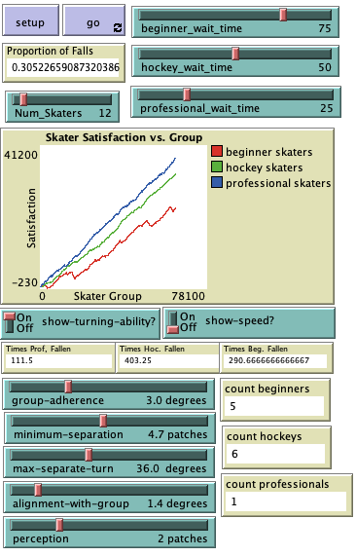

Another outcome from the model was that skater satisfaction was always highest for professional skaters and lowest for hockey skaters in the long term (roughly 30,000 ticks). The parameters that drove this outcome was particularly the wait time as all other changes to satisfaction were the same, but professional and hockey skaters had more time to skate around and increase their alleviation while beginner skaters spent extensive waiting time losing satisfaction after having fallen. There were rough thresholds for the number of skaters before one of the skater types began to lose satisfaction. As shown below, 18 skaters was generally the breaking point before beginner skaters started to lose satisfaction after 30,000 ticks.

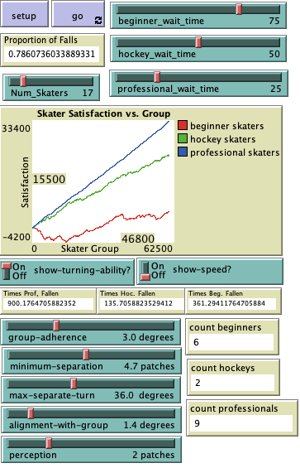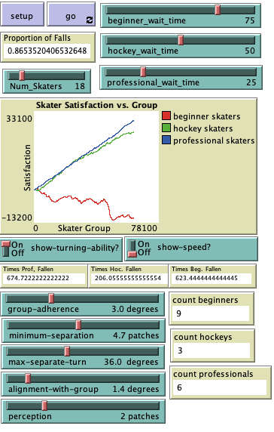

34 skaters was the breaking point before hockey players began to lose satisfaction after 30,000 ticks.

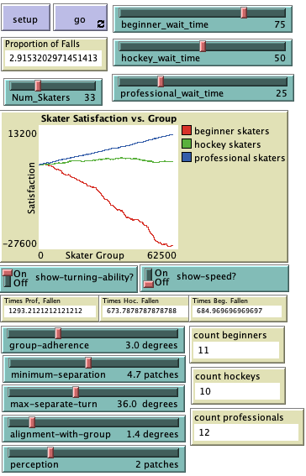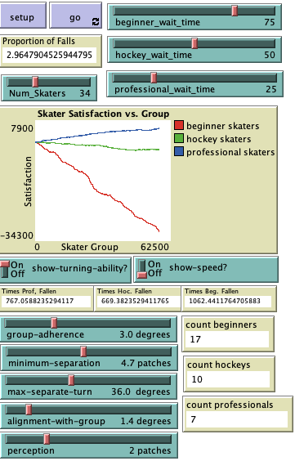

42 skaters was the breaking point before professional skaters began to decrease in satisfaction after 30,000 ticks.

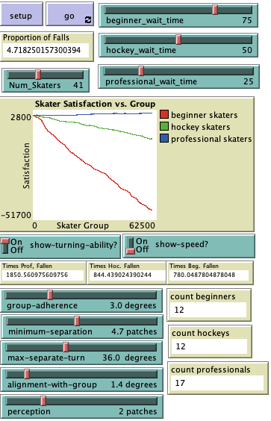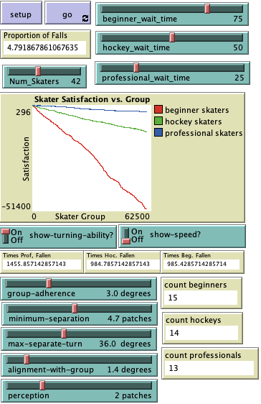

An extension of the skaters in an rink model could involve the addition of extra spinning, idling and rotating in the end zones (light blue regions) and the center square, where skaters would spend more time skating at. This is a key addition as public skating rinks often follow the rule of skating along traffic, but practicing in the middle or at the deep ends of the rink where there is light traffic. Another possible implication of the ice skating rink model would be adding obstructions in the ice to further replicate a real figure skating environment. This ice rink model may also be modified by making some skater agents leave the rink after they have fallen a certain number of times and sprout a new skater in its place to observe any changes in the emergent movement of the skaters in the rink. Having implemented a new model where skaters idle at the end zones and center of the rink, we notice that it yields movements more riddled with random movement. The proportion of falls remains to be around 31% for 12 skaters in the rink despite skaters’ idling. However, some trials yielded percentages greater than 31% or even a little lower than 31%. This demonstrates that the falling proportion among skaters is dependent on the variation between each skater, caused by their speeds and wait times, as well as the number of skaters in the rink. Naturally, more skaters in the rink increase the chances of there being fast professional and hockey skaters in the same rink with the beginner skaters, which inevitably leads to higher falling proportions. Interestingly, the skater satisfaction against time plot yields the beginner skaters experiencing the least satisfaction increase among the three skater types although they tend to fall the fewest amount of times, which is the same as in the original model. However, the new model results in both professional and hockey skaters increasing in satisfaction regardless of the number of skaters in the rink, as shown below.

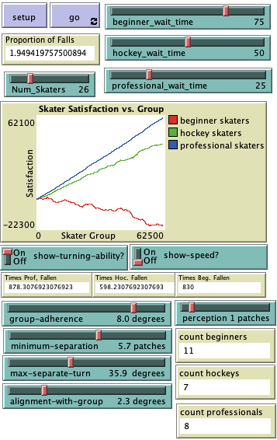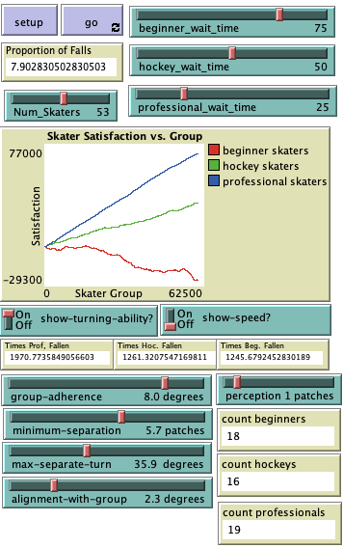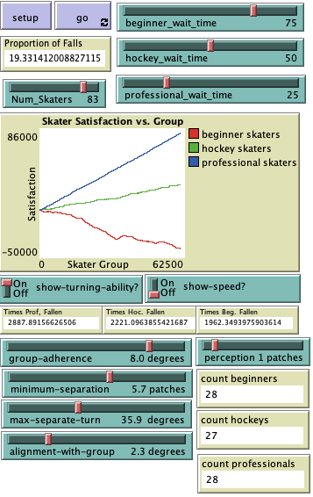

Ultimately, our objective from the skaters on an ice rink model was to observe any emergent skater movements as well as changes in their satisfaction while on the ice. The skaters in an ice rink model sheds insight on constrained flocking behavior with agents being able to fall. The model produced a few new insights about how there is a threshold number of skaters before everyone is worse off, or decreasing satisfaction, in my basic model, 12 skaters optimally represents a 31% fall rate, and skaters tend to settle into a global movement. Having run a simple model of the skaters and the new model of the skaters idling at the end zones and center square to practice, future direction for this model may involve modifying the behavior of the skaters to exit the model after falling a certain number of times before they cannot tolerate anymore falls. The exiting of skaters in the model could be coupled with the time limit of a real-life skating session as the program could stop after a certain number of ticks.

References

1. Broad, Nicolas R. “A Comparison Between Elite and Recreational Skaters’ Foot Pressure Patterns during Backward Cross-Overs.” *Library and Archives Canada*, (2006): 2-112
2. Kim, Sungwoon, and Jingu Kim. “Mood after Various Brief Exercise and Sport Modes: Aerobics, Hip-Hop Dancing, Ice Skating, and Body Conditioning.” *Perceptual and Motor Skills* 104, no. 3_suppl (June 2007): 1265–70
3. Mapelli, Andrea, Renato Rodano, Angelo Fiorentini, Andrea Giustolisi, Fernanda V. Sidequersky, and Chiarella Sforza. “Body Movements during the off-Ice Execution of Back Spins in Figure Skating.” *Journal of Electromyography and Kinesiology* 23, no. 5 (2013): 1097–1105
4. Pappas, Nick T., Patrick C. McKenry, and Beth Skilken Catlett. “Athlete Aggression on the Rink and off the Ice: Athlete Violence and Aggression in Hockey and Interpersonal Relationships.” *Men and Masculinities* 6, no. 3 (January 2004): 291–312
5. Pavlos Antoniou, Andreas Pitsillides, Tim Blackwell, Andries Engelbrecht, Loizos Michael. “Congestion control in wireless sensor networks based on bird flocking behavior.” *Computer Networks*, Volume 57, Issue 5 (April 2013): 1167-1191
6. Radford PJ, Williamson DM, Lowdon IM. The risks of injury in public ice skating. *British Journal of Sports Medicine* 1988;22:78-80